|  |
| --- |
| http://harmeetgabha.com/wp-content/uploads/2012/08/Eifel-Tower.jpg |
| **A Level** **French** |

**INFORMATION BOOKLET**

**&**

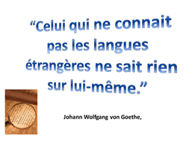**INDEPENDENT SUMMER TASKS**

CONTENT:

BIENVENUE À LA CLASSE DE FRANÇAIS À ARDEN ACADEMY………………P.2

1. INDEPENDENT SUMMER TASK INCLUDING USEFUL WEBSITES….……….P.3
2. MATERIAL AND RESOURCES………………………………………………………………..P.4
3. LESSONS AND LEARNING EXPECTATIONS…………………………………………….P.5
4. ORGANISING YOUR FOLDER AND OUTLINE OF THE COURSE ……………… P. 6
5. ASSESSMENTS & EXAMS DESCRIPTION………… …………………………………..P.8

GETTING READY FOR THE COURSE INCLUDING TIPS OF HOMEWORK…. P.9

1. LIST OF KEY GRAMMAR TO BE COVERED AT A LEVEL……………..…………..P.10
2. KEY LANGUAGE FOR STRUCTURE………………………………………………………..P.11

*Contacting the M.F.L department if you need more information:*

Mr I.Edgington, Head of M.F.L, iedgington@arden.solihull.sch.uk

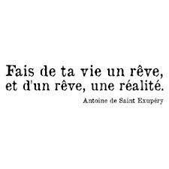First of all we are delighted to see you here today to help you make the right choices for your A-Levels. An A-level in French is seen as a very desirable subject by universities.

Having an A-Level in a language shows you are a competent linguist and is sought-after by employers in all spheres of work. It is more than just a qualification though, and we hope that it will be the catalyst for exploring the language, culture and history of the French-speaking world.

There are more French-speaking countries (France, Belgium, Switzerland, Luxembourg, Monaco) in Europe than any other language and globally it is one of the most spoken languages. The French language, culture, law, politics, history and society have influenced the development of other societies around the world.

Learning a language at A-Level helps you really become an independent, confident language speaker. It is challenging, but speaking a language at this level will be a huge asset to you in whatever path you follow.

Bon courage!

**INDEPENDENT PREPARATION FOR THE COURSE**

**Tasks for September are 1-3 below**

* 1. **Film Choices.**

We are likely to be studying ‘Un Long Dimanche de Fiançailles’. Watch the film and try to summarise it in French.

* 1. **Write a short text (100 – 150 words)** in response to the following question: *‘Pourquoi as-tu choisi d’étudier le français?’* You could reflect on your previous experiences of studying French your hopes for the course and plans for the future. Check the accuracy of your work carefully and try to use a range of different language structures. Be as creative as you like!
  2. **Look at any 5 of the following useful websites to prepare for the A Level course in September:**

**Listening**

[www.euronews.net](http://www.euronews.net)

Select language ‘français’ and then choose from a wide variety of News videos.

[www.20minutes.fr/](http://www.20minutes.fr/)

[fr.news.yahoo.com/](http://es.news.yahoo.com/)

[www.radiofrance.fr](http://www.radiofrance.fr)

<http://www.zut.org.uk/advanced/year12.html>

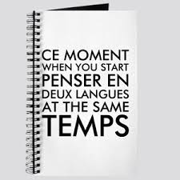**Grammar**

[www.swarthmore.edu](http://www.swarthmore.edu)

* French
* Links and resources
* Grammar

<http://fog.ccsf.cc.ca.us/~creitan/grammar.htm>

<http://www.nelsonthornes.com/secondary/modern_lang/ap/default.html>

* grammarNet

<http://atschool.eduweb.co.uk/stpmlang/languages.htm>

* interactive exercises

[www.languagesonline.org.uk](http://www.languagesonline.org.uk)

<http://www.columbia.edu/~ab410/drills.html>

**Reading**

[www.bbc.co.uk/languages/french/news](http://www.bbc.co.uk/languages/french/news)

The best place to start is the BBC’s languages web-pages. Choose the “**reportages**” link to find articles with a variety of reading exercises. The articles are archived into topic areas that relate to the AS and A level syllabus.

Some of them include audio clips so you can base your listening task on the same topic.

[www.lemonde.fr](http://www.lemonde.fr)

French daily newspaper. The website gives you access to all of the day’s news articles.

[www.lefigaro.fr](http://www.lefigaro.fr)

French daily newspaper. The website gives you access to the day’s news articles although you may require a subscription to view the majority of the articles in full.

[fr.news.yahoo.com/](http://es.news.yahoo.com/)

**Vocabulary and Grammar**: [www.languageperfect.com](http://www.languageperfect.com)

MATERIALS AND RESROURCES

We recommend that you purchase the following resources for use during your A-Level.

* At Arden, we study using ***AQA Textbooks***. We ask our students to purchase Year 1 book in Year 12 before starting in September. It is essential that students bring their textbook to every lesson. We have found very useful when students take notes or stick post-it notes in them. Students will also have the digital version ***Kerboodle.com*** and will be provided with a Username and Password at the start of the academic year.
* A Level and AS French – Grammar and Translation Workbook (Oxford by Steve Harrison). We will use this for the Flipped Learning schedule.
* Mot à Mot New Advanced French Vocabulary book (for vocab revision and consolidation)
* French Verb Wheel (to help you look up verbs and tenses more quickly)
* Collins Robert or Oxford Hachette French Dictionary
* A folder with file dividers (see p.1)

We will provide you with an exercise book, booklets for the film and book as well as specimen task booklets, a vocab and grammar book and a free Language Perfect account

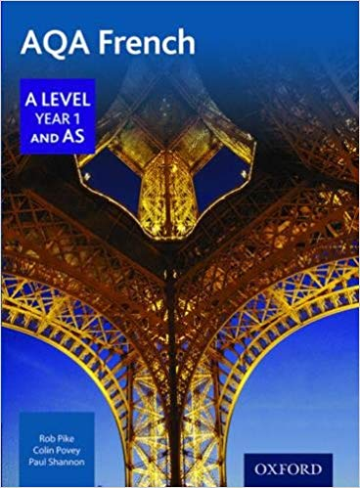

**YEAR 12 YEAR 13**

|  |
| --- |
| AQA A Level Year 2 French Student Book |

**R 12YEAR 13**

**LESSONS AND LEARNING EXPECTATIONS**

What are lessons like?

In lessons you will come across a wide range of activities which will test your developing language skills. You might give presentations, take part in debates and role plays as well as more complex listening and reading texts. Often you will be looking at how issues relate to society in France or a French-speaking country. Recent events that we have covered include ‘Les Gilets Jaunes’ and the rise of Marine Le Pen.

In addition to lessons you will also have **opportunities to speak French 1 to 1 or in a very small group each week**.

In 6th form you will be taking more initiative in organising your own studies. As well as set homework you will have self-study packs which we call **“Flipped Learning”** to help you with all your language skills, to broaden your general knowledge of Political and Cultural aspects of France and Francophone countries as well as developing ways to enrich your independent learning.

Use your private study time to develop your independent study skills (not just to complete homework!). Use online resources such as Kerboodle for **explicit exam practice**, or for more general information read French newspapers or blogs. Useful links can be found at the end of this document.

**Learning outside of the Classroom**

We offer debates competitions, Business Language Champions, European Young Translators Competition and other themed days in French It has proven to enhance and supplement any thinking and speaking skills. In addition we could help you to organise work experience in a French speaking country.

|  |
| --- |
|  |
|  |

**ORGANISING YOURSELF AND YOUR STUDY FOLDER**

A well organised file is the key to success at A-Level French. If you keep to these guidelines you will have no difficulty in keeping yourself prepared for lessons and keeping up with what is expected of you. Please label your file dividers as follows:

**Topics to be covered in Year 12:**

* **i) Aspects of French-speaking society: current trends**
* a) Family and relationships (marriage, partnerships, what is a ‘perfect parent’?)
* b) New Technology (how does technology help your life? Could you survive without the internet? Risks and dangers of our ‘cyber society’)
* c) Volunteering (Why help out? What’s in it for the volunteer?’)
* **ii) Aspects of French-speaking society: current issues**
* a) France and its culture – a country proud of its heritage)
* b) Contemporary music in France (how can we protect authentic French music? Why listen to French rap, rock and pop, Rn’B, dance?)
* c) Cinema – the ‘7th art’ (the importance of French cinema in the global world. What makes a great French film?)

**iii) Grammar:**

Each week you will be asked to do specific ‘flipped learning’ exercises for grammar or another skill from the A-Level French and AS Grammar and Translation Workbook’.

**iv) Oral work & oral exam preparation**

* When you are given hand outs, please ensure that they are filed in the appropriate section of your folder. If you miss a lesson for any reason, it is your responsibility to get a copy of anything handed out.
* It is essential that you bring your file to every lesson.
* 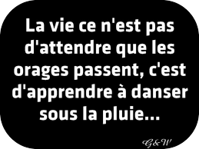It is your responsibility take good care of the text books you are given. They must be returned to school at the end of the course in the *same state* that they were given to you, so you may wish to cover them. The text book is:
  + AS AQA French A Level Kerboodle– Year 1 & AS (Oxford)
* Your teacher will tell you which books you will need for each lesson. In general you will need the AS AQA book for every topic lesson, and the grammar and vocabulary books can be used at home, to supplement your class work.
* Use your private study time to develop your independent study skills (not just to complete homework!). Use online resources such as Kerboodle for explicit exam practice, or for more general information read French newspapers or blogs. Useful links can be found at the end of this document.
  + My Kerboodle Log-in: ____________________
  + My Kerboodle Password: __________________

**Film and French Literature**

In lessons, we will study a classic modern film –***Un Long Dimanche de Fiançailles* (2004)– in years 12 and 13** and a modern French novel – **Delphine de Vigan *‘No Et Moi’*-in year 13.**

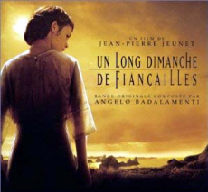

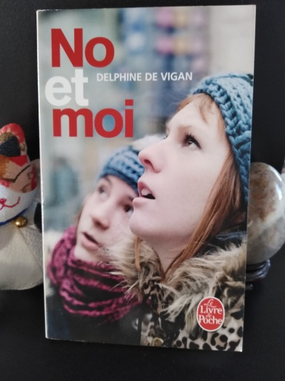

We will discuss the aspects of each pieces and relate it to topics that we learn during the 2 years. This is a great way to develop oral and written structured discussions.

What is my Point?

Where is my Evidence?

What is my Analysis?

Drawing conclusions from your arguments is a Key Skill for A-Level French.

**ASSESSMENTS:**

**We have a number of key assessments in French which will initially be in Listening, Reading, and Translation. You will be able to use your own headphones with a computer for the Listening, so that you can listen to the material as many times as you like within a specific time limit. Later on the year you will be expected to do speaking and written essays (based on the film).**

**You will be given feedback with strategies to improve for the next assessment.**

**EXAMS AND ASSESSMENTS**

We will be taking all of **our exams at the end of the two years**, so at the end of Year 13.

These will consist of:

**Paper 1: Listening, Reading and Writing (Reading, Listening and Translation paper** covering all of the topics from the two years. )

**Duration: 2 hours 30 minutes; total raw mark: 100**

**Paper 2: Writing (**You write two essays on the film and book you have studied, as well as doing an English to French translation.)

**Duration: 2 hours; total raw mark: 80**

**Paper 3: Speaking (**discussions of 1 of the topics you have studied, entitled a *Stimulus Card,* as well as your *Independent Research Project* which you will undertake over the course of the two years.)

**Duration: 21–23 minutes; total raw mark: 60**

During Year 12 you will also have series of assessments and mock exams in order to prepare you and also ensure your progress. For the essay it is important to check for grammatical accuracy. The following ideas should be helpful.

**Check verbs-** tense & person + endings**, check adjectival agreements** and remember you want to try to include a **variety of structures and tenses eg:**

* En ce qui me concerne
* Impersonal ‘on’ and ‘il’ phrases, e.g. on peut dire que, on dit que, il faut dire que
* Adverbs : probablement
* Negative, e.g. ne…..pas, ne….jamais (never), ne….que (only), ne ……rien (nothing) , ne…..personne (nobody), ne…….ni…….ni (neither….nor), ne…..aucun(e) (not a single), ne……….guère (scarcely/hardly)
* Advanced opinions: Je dirais que, il va sans dire que, pour ma part, en ce qui me concerne

***Check spellings and remember you are in control – it’s your opportunity to shine and show the progress you’ve made since GCSE– if you know something is incorrect –do not use it!***

**WHAT CAN I DO TO BE READY FOR THE COURSE AND SUBSEQUENT ASSESSMENTS?**

* Revise key vocabulary from the topics covered throughout the year (see below) but it is also a good idea to look over GCSE vocabulary too.
* Revise verbs, tenses and grammar points covered for GCSE.
* All vocab is listed in Kerboodle and you will have a vocabulary booklet.
* Use useful revision sites (look at the sites listed at the end of this booklet)

**TIPS ON HOMEWORK**

**WHAT CAN I DO TO REVISE?**

* Revise key vocabulary from the topics covered throughout the year (see below) but it is also a good idea to look over GCSE vocabulary too.
* Look through previous Listening, Reading and Writing practice, especially past papers.
* Revise verbs, tenses and grammar points covered this year (see list below)
* Use your grammar notes
* Use useful revision sites (look at the sites listed at the end of this booklet)

**IMPORTANT NOTE FOR HOMEWORK AND FLIPPED LEARNING**

• All homework must be completed for the due date and all tasks completed/attempted.

* It must be referenced appropriately: student’s name, date, chapter title/grammar point studied, page and exercise number, name of teacher concerned.
* Once ***feedback*** has been given from teacher, ***action must be taken by students*** to correct their own mistakes (this must be done in a different colour pen).
* All homework must be filed appropriately in your French folder or written in your French exercise book.
* ***Independent learning must be completed regularly*** in your grammar workbook or filed in your French folder.
* All written work in French must be proof-read: Please check the following

🞏 spellings

🞏 accents

🞏 adjectival agreements

🞏 verb endings

🞏 tenses

🞏 word order

* Once feedback has been given from teacher, action must be taken by students to correct their own mistakes (this must be done in a different colour pen).

**GRAMMAR**

* Nouns
* Quantifiers/Intensifiers
* Adjectives
* Comparisons (plus….que/moins…que)
* Possessives (mon/ma/mes)
* Adverbs (plus vite)
* Pronouns (il/elle/je/on)
* Prepositions

(à côté de, en face de)

* Conjunctions

(parce que/car/puis)

* Negatives (see list above)
* Subjunctive mood (bien que/il semble que)
* Verbs – regular, irregular, reflexives, perfect, future, conditional, imperfect, pluperfect and future perfect, future conditional, passive)

MCj03391840000[1]**USEFUL ESSAY TERMINOLOGY**

**★ INTRODUCTORY REMARKS**

|  |  |
| --- | --- |
| D’abord  En premier lieu  Deuxièmement  Je vais/On va…… discuter  On va…… étudier/examiner  Le réalisateur, que j’ai étudié, s’appelle..  La question est donc de savoir...  Ce que je trouve le plus intéressant, c’est…  Il faut se demander si  On doit considérer deux aspects  Il faut considérer les avantages et les inconvénients  Il est bien connu que | *First of all*  *First(ly)*  *Secondly*  *I am going/ we are going to talk about/*  *We are going to examine/ study*  *The director I studied is called…*  *The question therefore is*  *What I find most interesting is…*  *We have to ask ourselves whether…*  *We have to consider two aspects*  *We have to weigh the pros and cons*  *It is well known, that…* |

**★ PERSONAL COMMENTS**

|  |  |
| --- | --- |
| A mon avis/selon moi  En ce qui me concerne  Quant à moi/ Pour ma part  A mon sens  Il me semble que  Il semble que  J’estime que  Je soutiens que  Je suis d’avis que -  Je suis persuadé que/convaincu que  Je pense que/J’estime que  Je crois que  Je trouve que  Je suis certain/sûr que  Je dirais que | In my opinion  As far as I am concerned  As for me  As I see it  It seems to me that (not subjunctive)  It seems that (+ subjunctive)  I consider that  I maintain that  I’m of the opinion that  I am convinced that  I think that  I believe that  I find (that)  I am sure that…  I would say that… |

**★ IMPERSONAL EXPRESSIONS**

|  |  |
| --- | --- |
| Mieux vaut faire X que de faire Y -  Il est évident que  Il est hors question que  C’est un argument de poids  Il y a bien des mérites à faire - | *It is better to do X than to do Y*  *It is obvious that…*  *It is unquestionable that…*  *it’s a forceful argument*  *There's a lot to be said for* |

**★ CAUSE AND EFFECT RELATIONSHIPS**

|  |  |
| --- | --- |
| Par conséquent  Donc  Pour cette raison  C’est à dire  D’ailleurs  puis  car  étant donné que  puisque  Cet exemple montre que  Il va sans dire que  Néanmoins/ quand même  (il) reste que  pour autant  quoi qu'il en soit | Consequently  Therefore  For this reason  That is to say / namely  Besides  Then  For (in sense of because)  Given that  since (in sense of because)  This example proves that…  It goes without saying that…  Nevertheless  the fact remains that  for all that  be that as it may |

**★ CONTRADICTING**

|  |  |
| --- | --- |
| Mais  pourtant  par contre  De toute façon  D’une part  D’autre part  Bien que + subjunctive  malgré  en effet  comparé à/par rapport à | *But*  *However*  *On the contrary*  *Actually*  *On one hand…*  *On the other hand*  *Although*  *Despite …...*  *In fact*  *Compared to* |

**★ CONCLUSION**

|  |  |
| --- | --- |
| Pour conclure/en conclusion  En guise de conclusion  Enfin  Bref  En somme  Comme j’ai expliqué  Comme j’ai noté  On peut conclure que  A la suite de  Cela revient à dire que... | *In conclusion*  *To sum up*  *Finally*  *In short*  *All things considered*  *As I have explained*  *As I have stated*  *We can conclude that…*  *As a result of*  This boils down to saying that... |